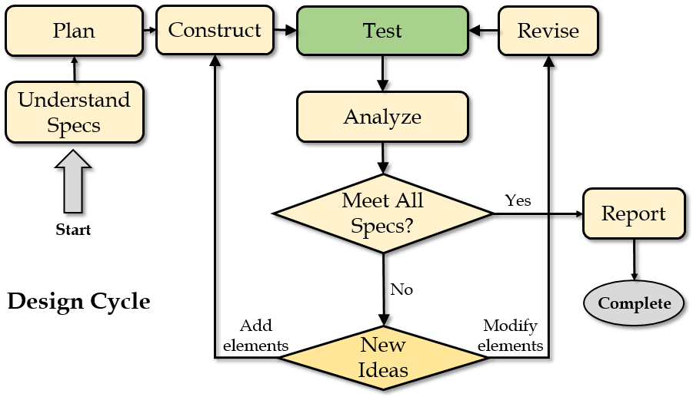
Solar panels convert sunlight into electricity that can power a house. In this engineering project, you are challenged to design a solar panel array for the roof of your own house that would produce as much energy as possible. If you don’t currently live in a house, you can choose your relative or friend’s house or choose from a few sample houses. Even if the house already has solar panels, completing the challenge may still help your family or friend figure out whether there would be a better system design. Your job is to use a computer-aided design and simulation tool called Energy3D to model your house and then come up with three designs under three different budgets ($20000, $40000, and $60000), following the engineering design cycle illustrated to the right.
Solarize Your House

Before you do anything, you should read this document carefully to make sure that you fully understand the design task. You will use the information you gathered in the Home Site Survey or Google Earth to model the house and tall surrounding objects such as trees. Once you have completed the model of your home you can begin exploring different solar panel layouts. You should also have obtained the electricity bills of your house from the past 12 months or longer. Energy3D can automatically calculate the monthly solar yields for each solar panel and contrast the total output with your monthly electricity usage. Based on your analysis of the results panel by panel and month by month, you will revise your design iteratively to improve the total output of the solar panels over the course of a year. Meanwhile, your design must meet the following specifications:
- The total cost of the solar panels must not exceed the budget;
- The layout must meet the safety requirement (e.g., all of them must be placed entirely on the roof with at least 1/3 of a meter distance from the edges or ridges of the roof on all sides);
- Solar panels must not ruin the curb appeal of the house (e.g., they must be neatly aligned).
- Select solar panels from the table below to design the most cost-effective solution

Brand | Max Wattage | Solar Cell Efficiency | Cost per Watt | Cost per Panel
SunPower X21-345 | 345 | 22% | $5.50 | 345W × $5.50 = $1897.50
SolarCity Triex340 | 340 | 20% | $4.50 | 340W × $4.50 = $1530.00
LG300N1C | 300 | 18% | $4.00 | 300W × $4.00 = $1200.00
Hyundai 280 | 280 | 16% | $3.50 | 280W × $3.50 = $980.00
Sharp NU-U235F3 | 235 | 14% | $3.00 | 235W × $3.00 = $705.00

Creating a 3D Model of Your House

For the solar analysis to be reliable, your 3D house model should represent the shape, height, and orientation of the house, the pitch of roof, the locations of surrounding trees, and all the rooftop structures such as dormers and chimneys as accurately as possible. This information can be gathered from Google Earth (see the Google Earth Instruction Sheet). If certain information is missing in Google Earth, you can always measure them at site using a ruler and the camera of your phone (see the Site Survey Instruction Sheet). As this may be the first time for you to draw a realistic-looking house in 3D, a collection of templates representing typical houses is also provided through Energy3D’s Templates Menu. To save you time, you should always select a template that most resembles the house you are going to model as the starting point. You will spend 2-3 hours to complete the 3D model of the house using Energy3D. Consult with the Energy3D Smartcards whenever you need help with the software.

Designing a Solar Panel Array to Meet the Energy Need
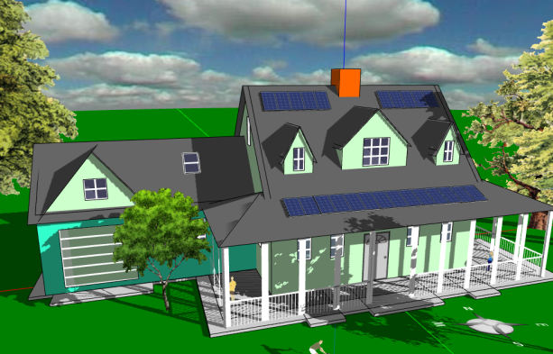
After you have created a 3D model of the house, you will spend another 2-3 hours designing, experimenting, analyzing, optimizing, and documenting your solar designs. Use the built-in analytic tools in Energy3D to carefully evaluate your options. At the end you will summarize the pros and cons of each design based on cost-benefit analysis and write a Solar Assessment Report addressed to the owner of the house. Until this project is over, you can always revisit and improve a design.

Instruction

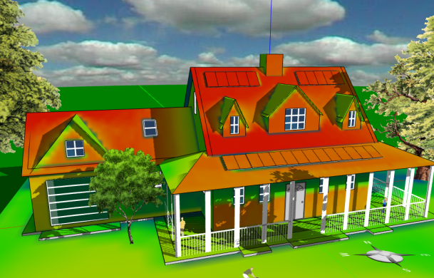
Remember, it is advised that you always start from a provided template, instead of from scratch. To get started,

- Write your name on the tag attached to your USB drive.
- Connect the USB drive to the computer and then open the USB folder on the computer.
- Double-click Energy3d.exe (Windows) or energy3d.jar (Mac) on the USB drive to run Energy3D.
- Once Energy3D is ready, use the Templates Menu to select a template that most resembles the house you are modeling. If needed, more templates are available through the menu Help>View Examples.
- Save the template you selected as a new file on the USB and start working on your project.
- At the end of each session, remember to save your work. You must save all your work in the USB drive (as you may use a different computer next time). At the end of a class period, do NOT just pull the USB drive out—use the EJECT function of the computer to safely remove it.

